Links to Home-Learning Wellbeing Activities
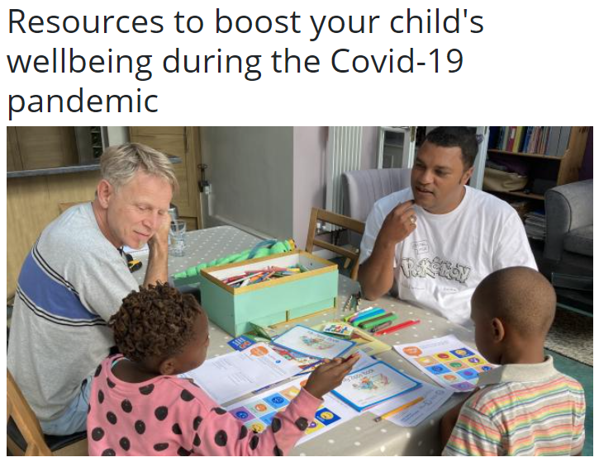 | https://www.partnershipforchildren.org.uk/what-we-do/childrens-wellbeing-activities-for-teaching-staff-and-families.html
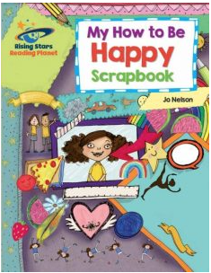 | https://drive.google.com/file/d/1OZp0WgFfgQNaJ_sseXdFFi4FIilEI2EP/view
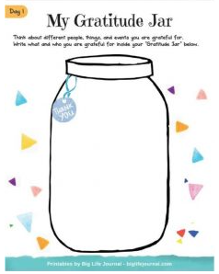 | https://drive.google.com/file/d/1UzVUh1Tb7W63gwQ6B5-8pmIUI4HZp_pl/view
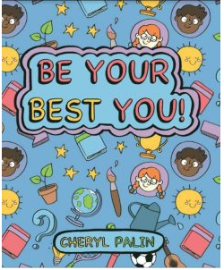 | https://drive.google.com/file/d/1uV8-Dr1viWx-hfrkPC1qNLzetHD3SERu/view
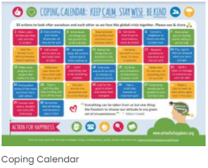 | https://drive.google.com/file/d/1dCoVxnv3VaIUXKa8LwouGhyURkhW_jFA/view
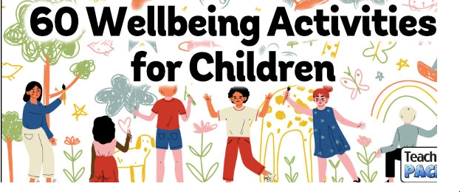 | https://www.teachingpacks.co.uk/60-wellbeing-activities-for-children/
 | https://www.5minutefun.com/wellbeing-activities-for-kids-stuck-indoors/

